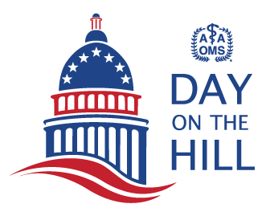
Congressional Feedback Form
2024 AAOMS Day on the Hill
Please email the completed form to Paula Kantas at pkantas@aaoms.org.
Your Name: |  |  |  |  | State:
Elected Official’s Name:
Who did you meet with? |  |  |  | Elected Official |  | Legis. Aide(s) |  | Both
Legislative Aide’s Name(s):

Student Loan Repayment Reform
Was the lawmaker supportive of AAOMS’s position? | Highly Supportive | Supportive | Not Supportive |  | Undecided
House – Is the legislator interested in cosponsoring the  Resident Education Deferred Interest (REDI) Act? |  |  | Yes | No |  | Maybe
Senate – Is the legislator interested in cosponsoring the  Resident Education Deferred Interest (REDI) Act? |  |  | Yes | No |  | Maybe
Any other comments or follow-up needed?

Craniofacial Anomalies
Was the lawmaker supportive of AAOMS’s position? | Highly Supportive | Supportive | Not Supportive |  | Undecided
House – Is the legislator interested in cosponsoring the Ensuring Lasting Smiles Act?
Senate – Is the legislator interested in cosponsoring the Ensuring Lasting Smiles Act? |  |  | Yes | No |  | Maybe
Any other comments or follow-up needed?

Drug and Supply Shortages
Was the lawmaker supportive of AAOMS’s position? | Highly Supportive |  | Supportive |  | Not Supportive |  |  | Undecided
House – Is the legislator interested in cosponsoring HR 6802? |  | Yes |  | No |  | Maybe
Senate – Is the legislator interested in cosponsoring S 2510? |  | Yes |  | No |  |  | Maybe
Any other comments or follow-up needed?

Grassroots/Political Action
Are you willing to serve as a key contact in your state and congressional district for legislative issues? | Yes | No
Are you willing to deliver an OMSPAC check to this electoral candidate if he/she meets OMSPAC selection criteria for the specialty’s political support? | Yes | No

